**Campaign Background**

* Dove, the brainchild of Unilever, gained immense popularity at the beginning of the millennium with its “Real Beauty” campaign. Real Beauty was initiated with the objective of challenging stereotypes related to beauty standards. The Real Beauty campaign was intended to promote a more inclusive and diverse portrayal of beauty.
* The world had never witnessed such a campaign, and being the first of its kind, the campaign gave Dove the momentum it had always desired. However, in 2017, an ad released as part of this initiative triggered an unexpected and vehement public backlash. The ad featured a sequence where a black woman appeared to transition into a white woman, sparking accusations of racial insensitivity and the perpetuation of harmful stereotypes. Almost instantly, social media catalysed the rapid dissemination of public outrage, amplifying criticisms and fuelling intense discussions about cultural representations in advertising. The timing couldn't have been more sensitive, as the broader socio-political climate was already fraught with heightened sensitivity to racial issues. The ad's implications struck a nerve, with many interpreting the sequence as reinforcing historical prejudices, associating beauty and cleanliness with whiteness while inadvertently devaluing blackness.
* As the controversy escalated, Dove was at the centre of a firestorm of criticism. The campaign, designed to celebrate diversity and challenge conventional beauty norms, faced severe backlash, tarnishing the brand's reputation. Accusations of a lack of cultural awareness and insensitivity were hurled at the company, amplifying the damage wrought by the ad's unintended implications. Beyond the immediate fallout, this incident resonated within the advertising industry, sparking introspection and debate. It became a pivotal moment, drawing attention to the necessity of thorough cultural sensitivity in marketing. The uproar prompted industry-wide discussions, underscoring the importance of aligning campaign narratives with inclusive values and cultural understanding to prevent the inadvertent perpetuation of damaging stereotypes.
* This controversy served as a sobering reminder to brands, highlighting the fine line between intention and interpretation in advertising. The fallout from this incident resonated far beyond Dove's immediate sphere, sparking a broader industry conversation about responsible and culturally sensitive marketing. It illuminated the need for comprehensive reviews and reinforced the imperative for brands to navigate the complex landscape of societal perceptions and historical contexts when crafting advertising narratives.
* As part of Dove's Communications team, our primary focus now is addressing the recent controversy head-on. The impact of the controversial ad within our 'Real Beauty' campaign has been significant, causing a profound erosion in public trust and affecting our brand's reputation. Understanding the far-reaching consequences beyond the immediate aftermath, we recognize the challenge this poses in connecting authentically with our audience. In response, we're actively steering a comprehensive crisis communication strategy. This isn't just about damage control; it's a concerted effort to rebuild and fortify Dove's unwavering dedication to inclusivity, diversity, and cultural sensitivity. Our goal isn't just to handle the problem now. We want to understand our audience better so that our future messages match what Dove stands for. This way, we can rebuild trust and create a genuine connection with everyone who believes in our brand. In addition to this, we're emphasising the importance of building stronger connections with our stakeholders and employees. We believe including their perspectives and insights to navigate this situation and emerge stronger together is vital.

**SMART Goals**

1. **Apology and Reconciliation (external):** Issue a public apology through a press release and social media and engage directly with a minimum of 6,500 affected individuals within the first month through social media platforms and forums, aiming for a 15% increase in positive sentiment among these individuals by the end of three months. Achieve a 25% increase in positive media coverage, highlighting our diversity initiatives within ten months.
2. **Industry Leadership (external):** Lead or participate in at least five industry forums or discussions within the first six months, aiming to garner at least 1,000 engagements or shares on social media platforms showcasing our commitment to promoting diversity and inclusivity in advertising.
3. **Surveys and Feedback (internal and external)**:

**Internal** - An extensive survey will be conducted for employees to share their workplace experience on whether they have faced discrimination from a superior or a coworker and how we can help their well-being. Monthly HR well-being reviews can be conducted where they can give feedback regarding their experiences.

**External** - Aim to receive feedback from at least 5,000 individuals through surveys, with a target of a 25% increase in perceived trust and satisfaction levels over six months.

1. **Cultural Sensitivity Training (internal):** Ensure a 95% completion of the mandatory cultural sensitivity training program for all marketing teams within six months, aiming for a 10% improvement in scores indicating understanding and applying cultural sensitivity principles. Feedback after 1 month should be conducted to see if the employees feel a change in the workplace post-training.
2. **Policy Enhancement (internal)**: Strive for a 15% increase in diverse representation in marketing materials and departments within the next six months, aligning with revised internal advertising policies.

* **Audience Analysis**

|  |  |  |  |  |  |
| --- | --- | --- | --- | --- | --- |
| **AUDIENCE** | **CATEGORY** | **GEOGRAPHY** | **PURPOSE** | **VALUES** | **METHODS** |
| Affected Communities | External | USA/  N. America | To maintain the brand image and regain trust | Inclusivity  Equality  Cultural Sensitivity | Social Media  News Release  Surveys |
| Women | External | Worldwide | Since women are our primary consumer base, we ought to maintain their connection with ‘The Real Beauty’ campaign and align with our values of empowering women. | Empowerment  Reassurance | Q and As  Social Media |
| Current and Potential Customers | External | Worldwide | To maintain a reasonable customer retention rate and loyalty while furthering brand advocacy and inspiring customer confidence. It exhibits transparency, accountability, and credibility. | Trustworthiness  Credibility  Assurance | Social Media  Survey |
| Internal Teams and Employees | Internal | USA/  N.America | Facilitating a safe work environment where the employees feel heard, seen, satisfied, and secure at their workplace. Sensitization training and policies can ensure the avoidance of workplace discrimination and more inclusivity. | Inclusivity  Safety  Assurance | CEO Blog  Corporate Email  Survey  Town Hall |
| Advocacy Groups and Organisations | External | USA/  N.America | Ensuring that we are listening and showing that we are mindful of diverse cultural backgrounds and experiences. We further provide cultural sensitivity and respect by avoiding reinforcing stereotypes and inadvertently causing offense. | Assurance  Diversity | Press Release  Q and As |

**Strategic Consideration -**

**Constant Social Media Monitoring:** Listening and evolving according to public perception of our statements about diversity through surveys and social media listening tools.

**Cultural Sensitivity:** Ensure cultural sensitivity in marketing materials by implementing pre-launch focus groups and post-campaign evaluations.

**Competitor Landscape:** Analyse competitors' diversity and inclusion approaches by regularly monitoring and analysing their campaigns and reactions.

**Advocacy Group Collaboration:** Strengthen partnerships with diverse advocacy groups, ensuring engagement and impact.

**Media Relations:** Prepare for media scrutiny and ensure consistent messaging by developing a crisis response strategy and assessing media coverage.

**Consumer Feedback Channels:** Enhance mechanisms for gathering consumer feedback by implementing surveys, feedback forms, and online forums. Facilitate two-way communication with the customers to be constantly in touch with the evolving environment.

**Employee Involvement:** Foster a culture of diversity within the organisation, tracking employee participation in diversity training and satisfaction.

**Market Trends:** Stay informed about evolving diversity and inclusion trends by analysing industry reports and conducting ongoing market research.

**Corporate Social Responsibility (CSR):** Align the campaign with our CSR initiatives, evaluating its impact on CSR goals and broader social responsibility.

**Global Sensitivity:** Consider cultural nuances on a global scale, adapting campaigns based on regional and cultural differences.

**Long-Term Impact:** Assess the long-term impact on brand reputation and market position by conducting periodic brand perception assessments and tracking market share changes.

**Communication Approach**

Reactive:

1. Immediate response - We will immediately notify all our key internal stakeholders and designate a spokesperson to ensure a unified and timely response to the situation. Immediate internal communications via email, intranet, or team meetings would be initiated to address the situation, acknowledging the crisis, and assuring employees that the company is taking action.
2. Transparent Communications - We would work closely with the PR, Marketing & HR teams to gather accurate information about the crisis and ensure that the messaging provided to employees is honest, consistent and aligns with external statements. Open and transparent communication channels would be established, such as dedicated forums, where employees can ask questions and receive updates about the ongoing efforts to address the issue. Clear and honest internal memos or newsletters would be distributed to keep everyone informed about the steps being taken to rectify the situation.
3. Corrective Actions - Collaboration with relevant departments would be crucial and we will facilitate discussions within Dove to determine immediate actions and long-term strategies. This might involve organizing internal workshops or training sessions focused on diversity and cultural sensitivity. Documenting these initiatives and communicating the commitment to change and improvement internally would be a priority. Regular follow-ups and updates to ensure employees are engaged in the implementation of these corrective measures would also be essential.

Proactive:

1. Preparedness - We will create plans which will outline steps on our immediate responses and train our team in cultural sensitivity and crisis management. We will also constantly monitor the social media trends for early detections for the future.
2. Consistent Messaging - We will be reinforcing the ‘Real beauty’ message consistently and ensure all departments understand and reflect organisational values.
3. Engagement & Feedback - We will encourage open dialogue through various channels which will involve our customers and employees as well. The emphasis will be on seeking and incorporating feedback for continuous improvement.

**Key Messages**

1. Dove is committed to promoting inclusivity and diversity, as it has been throughout the years.
2. We value feedback and strive to listen, learn, and grow as a community continuously.
3. Dove will continue to lead conversations and advocate for more responsible advertising practices within the industry.

**Tactics & Channels**

**Internal:**

1. CEO Blog
2. Corporate Email
3. Townhall
4. Surveys

**External:**

1. News Release
2. Social Media
3. Q&A
4. Survey

**Internal Communication Tactics Rationale**

**CEO Blog Rationale:**

Having a CEO blog is crucial for our internal communication as it creates a two-way communication channel to engage with employees and gain insights into their perspectives on issues related to the brand. It provides an accessible medium to connect with them, encourages the sharing of experiences, and serves as a platform to reiterate company values and goals. The CEO blog ensures all employees stay informed, updated, and understand company events.

**Corporate Email Rationale:**

Sending corporate emails to employees quickly and conveniently conveys important information. An email from the communications team will help address the primary concern and include the initial steps taken to resolve the situation. A corporate email is an efficient and quickly formatted way to communicate, with the added benefits of no reply-all mishaps and instant delivery to all employees.

**Town Hall Rationale:**

Town hall meetings allow managers to communicate openly with employees, creating transparency and building trust. They provide a forum for discussing company goals, challenges, and visions and promote two-way communication between workers and leadership. This inclusive environment fosters employee engagement and motivation, contributing to the organisation's success. It also helps manage worries during uncertain times. Leaders can give updates and reassure staff about measures being taken.

**Survey Rationale:**

The aim of this survey is to interact with our employees and obtain their feedback in an organized manner. Through surveys, we can discuss their experiences, level of satisfaction, concerns, and suggestions. Engaging employees demonstrates that their viewpoints are valued and helps create a more committed workforce. Using surveys to involve employees in decision-making promotes inclusivity. It communicates to staff members that their contributions are essential and encourages teamwork in decision-making.

**External Communication Tactics Rationale**

**News Release Rationale:**

News Media has a wide reach, and we are certain that releasing a press release in the early days of the crisis will help us calm the audience. Our News Release will act as a reply to all the criticism we have been receiving on the ad so the audience will realise that their voices are being heard and respected. We will be utilising our immaculate relationships with media firms to show our brand and campaign in a good light in order to shift public opinion. The News Release will help us kickstart our crisis management campaign, which will have a series of crisis management initiatives to help our brand get through this situation.

**Social Media Rationale:**

We plan to utilise various social media platforms, including Instagram, Facebook, and Twitter, to reinforce our dedication to promoting inclusivity and diversity in our community. Our target audiences frequently visit these channels to receive important updates and information about our products, making social media an efficient and quick way to reach a vast global audience in a timely and effective manner. Using relevant hashtags across different platforms allows our content to be easily discovered, interacted with, and tracked, thereby allowing for real-time feedback from our audience.

**Questions and Answers Rationale:**

The QnAs reflect Dove's commitment to transparency, accountability, and continuous improvement. They address key aspects of Dove's crisis management strategy, showcasing their dedication to learning from past mistakes, ensuring authentic representation across diverse identities, supporting underrepresented communities beyond marketing efforts, and measuring the impact of their initiatives. By providing these FAQs, Dove aims to demonstrate proactive engagement, transparency, and a steadfast commitment to diversity, inclusivity, and responsible practices.

**Survey Rationale:**

By taking an external survey of our existing consumers, potential customers and target audience, we will be able to define the public opinion on our brand and its product. Through extensive campaigning of racial inclusivity in our products, we have always been an unrivalled advocate for curbing racially discriminatory practices. The survey will help us gain the public view on our efforts to promote racial inclusivity.

**Campaign Timeline**

|  |  |  |
| --- | --- | --- |
| **Date** | **Internal/External Activity** | **Target Audience** |
| Oct 7th, 2017 | Facebook Ad Deleted | Consumers/Potential Customers |
| Oct 8th, 2017 | Press Release | Media/Journalists |
| Oct 8th, 2017 | Corporate Email | Employees |
| Oct 10th, 2017 | CEO Blog | Employees |
| Oct 12th, 2017 | QnA(Media Interview) | Consumers/Potential Customers |
| Oct 12th, 2017 | Town Hall Invitation | Employees/Stakeholders |
| October 14th, 2017 | Start-Off Sensitisation Training | Marketing Team |
| October 20th, 2017 | Internal & External Surveys | Employees/Consumers |
| October 20th, 2017 | Social Media Post | Consumers/Potential Customers |

|  |  |  |
| --- | --- | --- |
| **Budget Plan** | | |
|  |  |  |
| **Expenses** | **Budgeted** | **Actual** |
| Sensitization session (over 6 months) | $40,000 | $50,000 |
| Survey forums (internal and external) | $7,000 | $8,000 |
| Town Hall | $10,000 | $10,500 |
| Social Media Content | $25,000 | $22,000 |
| News Releases & Media Relations | $18,000 | $20,500 |
| Meetings with advocacy groups and organisations | $17,500 | $15,000 |
| Social Media and Survey Monitoring | $15,000 | $20,000 |
| **Total Expenditure** | **$132,500** | **$146,500** |

**Evaluation**

Our communication plan’s success will be measured in several ways to assess its effectiveness.

- Active monitoring of social media, news releases, and town hall to match the level of positive comments against the negative ones. Evaluate the impact of industry participation through social media engagement and shares within the first six months. Assess the opening rate and read rate of emails, usage of listening tools for measuring sentiments and feedback online, like buzzsumo, Hootsuite etc. Number of engagements or shares on social media showcasing commitment to diversity and inclusivity.

- Surveys and Feedback (Internal and External): Assess feedback from both internal and external stakeholders through surveys. The number of internal employees participating in surveys and HR well-being reviews. Percentage increase in perceived trust and satisfaction levels among external individuals over six months.

- Training for cultural sensitivity: By keeping an eye on completion rates and evaluating staff input. The proportion of marketing teams that finish the six-month cultural and sensitivity guidelines have improved. After a month, employees provide feedback to assess how the workplace has changed since the training.

- Employee feedback after one month to gauge changes in the workplace post-training. Monitor overall brand perception and trust. Number of internal employees participating in surveys and HR well-being reviews. Percentage increase in perceived trust and satisfaction levels among external individuals over six months.

The communication plan is well-structured, with clear objectives and measurable goals. It addresses internal and external stakeholders, showcasing a commitment to rebuilding trust and promoting diversity. The inclusion of cultural sensitivity training and industry leadership initiatives reflects a holistic approach to addressing the root causes of the controversy. Continuous monitoring and adaptation will be crucial for the plan's success.

PART TWO

**COMMUNICATION**

**TOOLKIT**

**Internal**

1. **CEO BLOG**

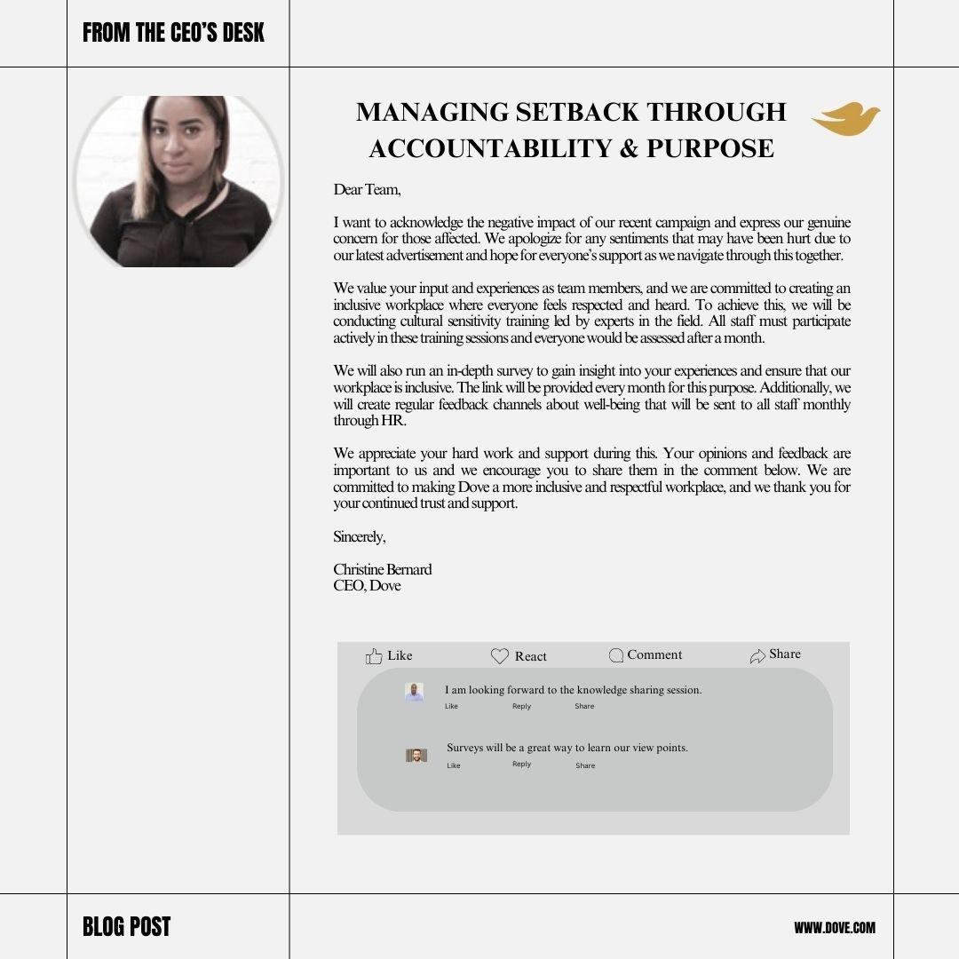

1. **Townhall Invitation**

Dear [Employee Name],

I would like to invite you to a Town Hall Meeting with all employees that will be held on 12th October 2017. The purpose is to discuss in detail the setback we had with our last campaign ad and our plans to overcome it. I highly encourage all the employees to attend this town hall, as it would help in clarifying everyone’s doubts and the negative press. As an organization, we remain committed to promoting beauty in all its forms and empowering individuals to embrace their uniqueness. We all know that our latest advertisement received backlash, and this has negatively impacted our reputation worldwide.

However, we all are working hard to overcome these challenges. I thank you all for your countless efforts.

I encourage you to attend this meeting and be a part of our discussion. During the meeting, you can come forward with all your queries and feedback you may have. It is also an opportunity for you to connect with other employees while enjoying light refreshments.

Please RSVP by 7 October 2017 to ensure we have adequate arrangements for everyone attending. You will be receiving further emails with more information about the meeting; for any queries, contact Riya Henry [HR department, riyahenry@gmail.com].

Looking forward to your participation.

Sincerely,

Christine Bernard

CEO, Dove

1. **Corporate Email**

From: [commsmanager@dove.com](mailto:commsmanager@dove.com)

BCC: Dove_Employees ([allemployees_dove@outlook.com](mailto:allemployees_dove@outlook.com))

Subject: Dove's Commitment to Our Values: Your Vital Role

Dove’s pledge to inclusivity

Dear Team,

In light of recent events, I wanted to take a moment to reaffirm our dedication to inclusivity and diversity. Our values are the cornerstone of everything we do; Your voice matters now more than ever. Your insights and perspectives are invaluable as we navigate challenges and reinforce our commitment to representing the beauty of diversity.

Moving forward, we are prioritizing internal initiatives to ensure our practices align even more closely with our core values. This includes tailored training sessions and workshops aimed at strengthening our approach to inclusivity within our campaigns. After the mandatory training process, all the employees will be assessed on their performance and learnings. Together, we are pivotal in restoring trust and unity, not only within our team but also among our valued consumers.

Please stay engaged and feel free to share your thoughts. Your active participation is important in shaping our ongoing commitment.

For further details on our initiatives, refer to internal communications channels or reach out to your department heads.

Thank you for your ongoing support and dedication to our values. Together, we'll continue to champion diversity and inclusivity in all that we do.

Sincerely,

Christine Bernard

CEO, Dove

1. **Internal Survey:**

<https://docs.google.com/forms/d/e/1FAIpQLSchTZ843AyJCgD9MhnhMHwvP-dFG5jZQlqCNl9ns8Xxi9Ldkw/viewform?usp=sf_link>

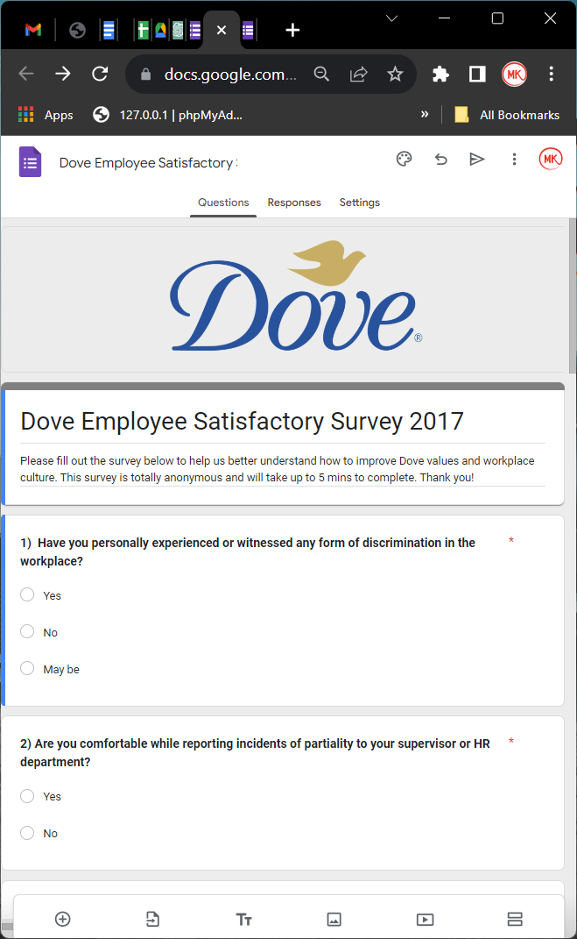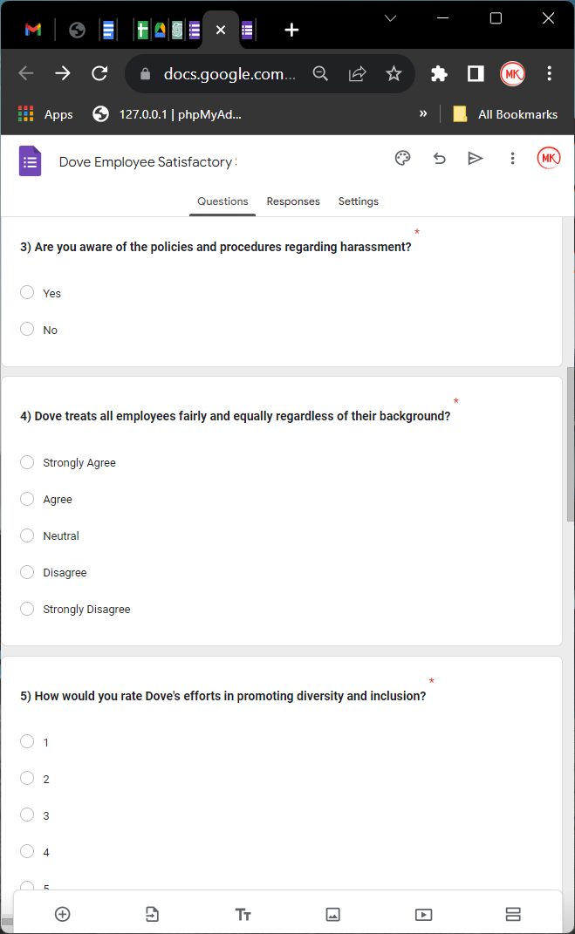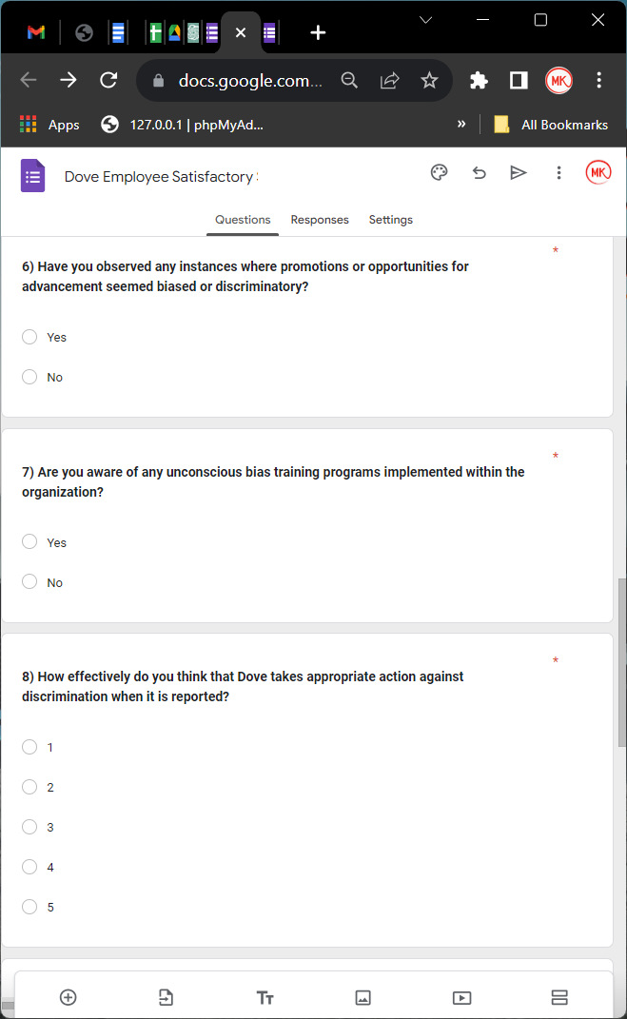

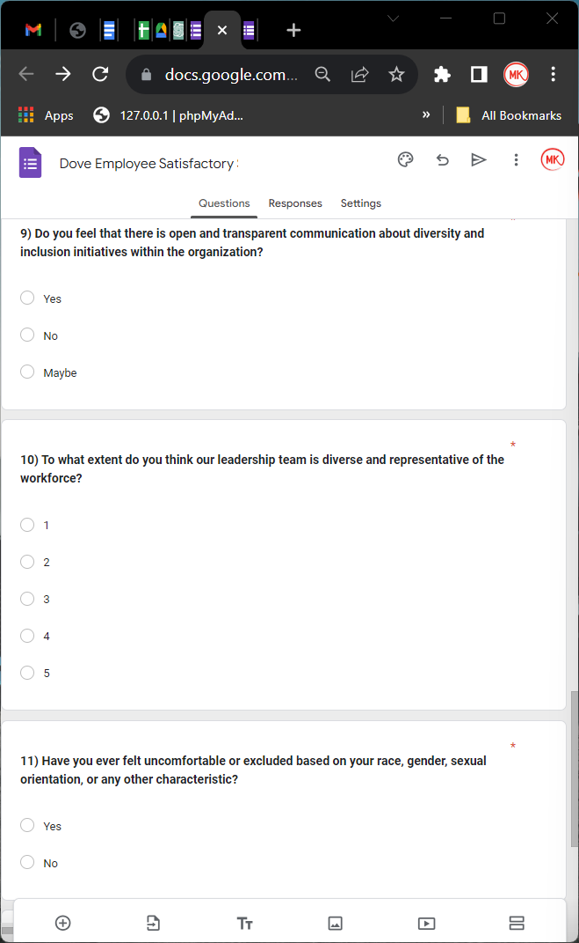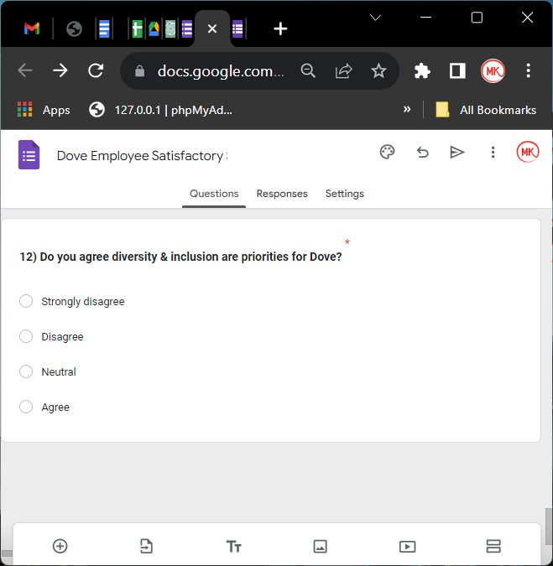

**External**

**News Release**

**FOR IMMEDIATE RELEASE**

**Dove’s Response to The Recent Body Wash Ad**

**Dove Addresses the Rising Questions on the Brand’s Racial Inclusivity**

**New York, USA, October 08, 2017 -** In response to the recent backlash on a Facebook Ad featuring Dove’s Body Wash, Dove is taking immediate action to assure its large and diverse consumer base that the brand does not support racial inequality in any way and will continue to lead conversations and advocate for more responsible advertising practices within the industry.

On the 6th of October, Dove found itself amid a chaotic rubble left by its newly released body wash ad on Facebook. The ad triggered the sentiments of the audience and sparked controversy. The ad was immediately deleted by Dove’s media team. However, the damage had been done.

The ad in question was a part of Dove’s much-acclaimed Real Beauty campaign. Since then, the company has been trying to accept feedback and criticism from the public and ensuring that the campaign and the brand do not condone racial insensitivity. “We value feedback and strive to listen, learn, and grow as a community continuously.” said the Co-CEO of Dove, Christine Bernard.

Dove is now making enormous efforts to assure its consumers and the target audience that it is committed to promoting inclusivity and diversity, as it has been throughout the years. Jennifer Pandelidis, CO-CEO of Dove, emphasized, "Dove has always been vocal about its efforts to promote racial inclusivity and body positivity and we are ensuring that something like this never occurs again".

**About Dove:**

Dove, a brand under the multinational consumer goods corporation Unilever, has been a trailblazer in the beauty industry since its inception in 1957. Committed to fostering a world where beauty is a source of confidence and not anxiety, Dove has championed inclusivity, diversity, and body positivity through its innovative products and impactful campaigns. For more information about Dove and its initiatives, please visit <https://www.dove.com/>

-30-

**Media Contact:**

Viktor Feckles

Dove Communications

+1 437 438 9649

[Feckles@Dove.com](mailto:Feckles@Dove.com)

**Social Media Posts**

Facebook

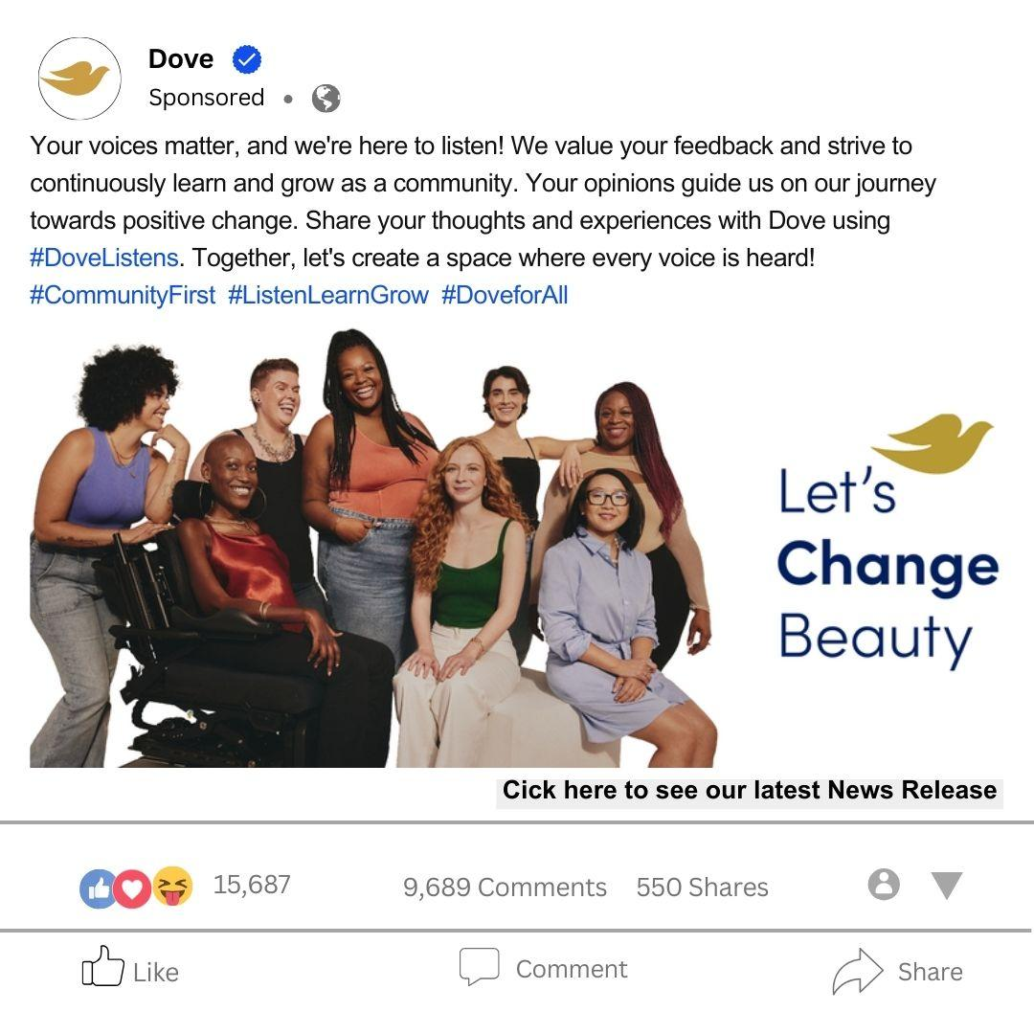

Instagram

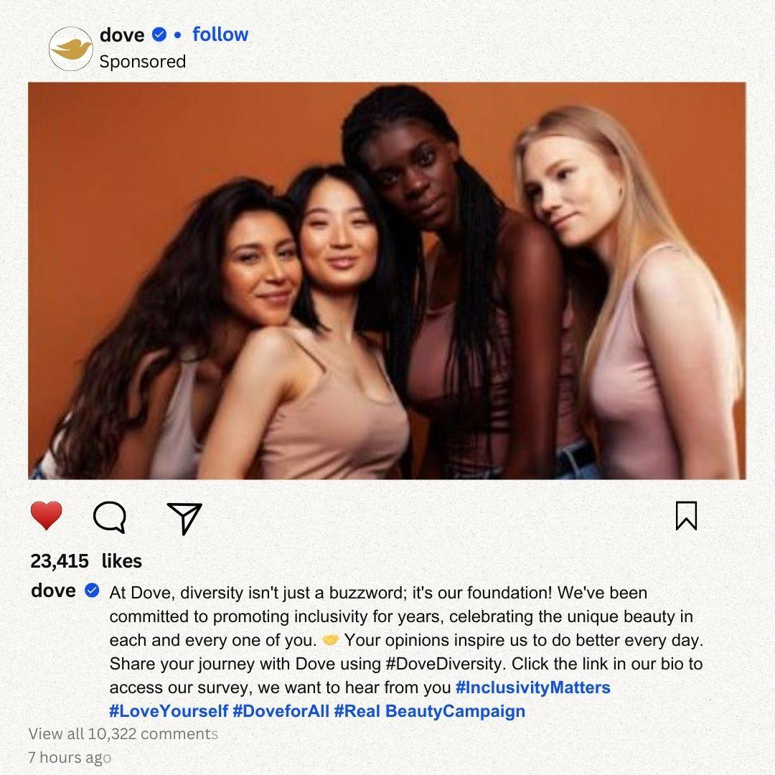

Twitter

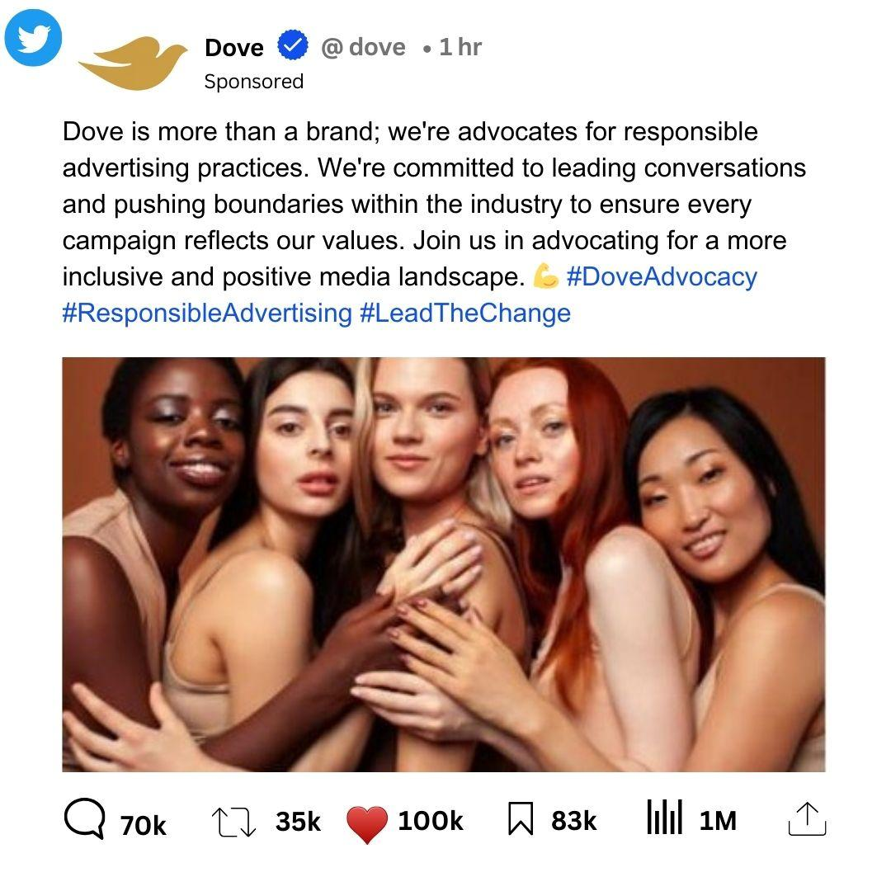

**Questions & Answers**

**Q1: What measures has Dove implemented to prevent similar incidents in the future?**

A: Dove has reinforced its internal review processes with more stringent guidelines for cultural sensitivity and diverse representation. This includes the establishment of dedicated review panels composed of individuals with diverse cultural backgrounds to provide nuanced perspectives. Additionally, comprehensive and ongoing training programs have been introduced across all teams involved in campaign development. These programs cover topics such as cultural awareness, unconscious bias, and ethical advertising practices, fostering a more inclusive approach in all phases of campaign ideation, creation, and approval.

**Q2: Who is held accountable for the oversight in approving the controversial ad?**

A: In response to the oversight, Dove conducted thorough internal reviews and initiated systemic improvements across the approval process. Accountability extends across teams involved in campaign development, where collective responsibility is taken to rectify oversights. These improvements involve rigorous checkpoints and a more collaborative approach among various stakeholders to ensure campaigns align with Dove's commitment to cultural awareness and responsible advertising.

**Q3: How does Dove plan to regain consumer trust and ensure its commitment to diversity?**

A: Dove's commitment to inclusivity remains resolute. We've initiated direct engagements with affected communities, advocating for open dialogue and actively seeking feedback. This collaborative approach allows us to incorporate community insights and perspectives into our future campaigns authentically. Embedding inclusivity involves more than just external messaging; it encompasses our values, operations, and actions. Dove is aligning its internal culture and external commitments to reinforce trust and demonstrate a sustained dedication to diversity and inclusivity.

**Q4: Will Dove continue its Real Beauty campaign or similar initiatives?**

A: Dove remains committed to celebrating diverse beauty. The essence of the Real Beauty campaign aligns deeply with our values of inclusivity and authenticity. However, Dove understands the importance of evolution and is continuously refining its strategies. We're actively reassessing our approaches, employing nuanced storytelling and imagery that authentically represent inclusivity and diversity without falling into stereotypes. Our goal is to evolve our initiatives while remaining true to the core principles of celebrating real beauty in all its forms.

**Q5: What lessons has Dove learned from this incident, and how will it shape future strategies?**

A: This incident has been pivotal in shaping Dove's approach moving forward. It has underscored the paramount importance of cultural sensitivity and authentic representation in our campaigns. Dove is integrating these learnings into its core strategies, ensuring that inclusivity and diversity are not just buzzwords but fundamental principles guiding our decision-making processes. We're instituting robust measures, from internal protocols to external engagements, to foster a more inclusive narrative that resonates authentically with our diverse audience.

**Q6: How is Dove ensuring that its internal teams understand and embody the values of diversity and inclusivity?**

A: Dove's approach to cultivating an inclusive culture goes beyond training. Alongside comprehensive training programs, Dove is fostering an environment that encourages open dialogue and embraces diverse viewpoints. Leadership actively champions inclusivity, creating spaces for team members to engage in discussions, share perspectives, and collaboratively develop campaigns that authentically represent diverse beauty. These initiatives aim to instill a deeper understanding and appreciation for diversity within our teams.

**Q7: How will Dove ensure diversity is not just a short-term response but a sustained part of its brand identity?**

A: Dove's commitment to diversity is deeply embedded in its long-term strategies. Beyond campaigns, Dove is integrating inclusivity into its core values and operations. From hiring practices that prioritize diversity to partnerships that support marginalized communities, Dove is continuously evolving and expanding its efforts. This commitment is being ingrained in every aspect of the brand, ensuring a sustained and authentic representation of diversity and inclusivity.

**Q8: How is Dove ensuring that the diverse voices of its target audience are represented authentically in its campaigns?**

A: Dove places a high value on authentic representation, actively engaging in a multifaceted approach to ensure genuine portrayal in its campaigns. We conduct extensive audience research, going beyond demographics to understand the diverse perspectives, experiences, and cultural nuances of our audience. This involves engaging with diverse focus groups, listening sessions, and collaborating closely with community leaders and advocates. By fostering these collaborations, we aim to co-create campaigns that resonate authentically with the diverse voices within our audience.

**Q9: What steps has Dove taken to ensure that its supply chain and partnerships align with its commitment to diversity and inclusivity?**

A: Dove extends its commitment to diversity and inclusivity throughout its supply chain and partnerships. We collaborate with suppliers and partners who share our values, ensuring alignment with responsible and inclusive practices. Our partnerships prioritize diversity, seeking suppliers and collaborators who demonstrate a commitment to ethical standards, fair representation, and inclusivity within their practices.

**Q10: How does Dove address the intersectionality of diversity, such as race, gender, age, and body type, in its marketing strategies?**

A: Dove's marketing strategies are designed to be intersectional, acknowledging the multi-dimensional facets of identity. We approach our campaigns with a deep understanding of the complexity and intersectionality of identities, ensuring our messaging celebrates and represents various dimensions of diversity. By acknowledging and celebrating these diverse intersections, Dove aims to create campaigns that resonate with the nuanced experiences of individuals across different identities.

**Q11: What initiatives does Dove have in place to support underrepresented communities beyond its marketing campaigns?**

A: Dove is deeply committed to supporting underrepresented communities through various impactful initiatives. Beyond marketing campaigns, we collaborate with organizations that champion diversity and inclusivity, actively providing resources, platforms, and opportunities to amplify diverse voices. Our initiatives extend to educational programs, scholarships, mentorship opportunities, and community engagement initiatives, striving to uplift and empower marginalized communities.

**Q12: How does Dove measure the impact and effectiveness of its diversity and inclusivity initiatives beyond surface-level representation?**

A: Dove recognizes the importance of meaningful impact assessment in its diversity and inclusivity initiatives. We employ a diverse range of qualitative and quantitative metrics to measure effectiveness. These include feedback from communities, engaging in ongoing dialogues, conducting qualitative assessments of representation and authentic portrayal, and using quantitative data analysis to gauge the impact of our efforts. These comprehensive assessments ensure that our initiatives drive meaningful change and have a tangible, positive impact on the communities we aim to support.

**4. External Survey**

Link to the survey:

<https://docs.google.com/forms/d/e/1FAIpQLSfuzbwY1fQRANLKCPdgJSNaAx72a3tbzMIehMlxHj3Ka6ycrw/viewform?usp=sf_link>

